**DSP Experiment 13 – Output**

**Interpolation of Signal**

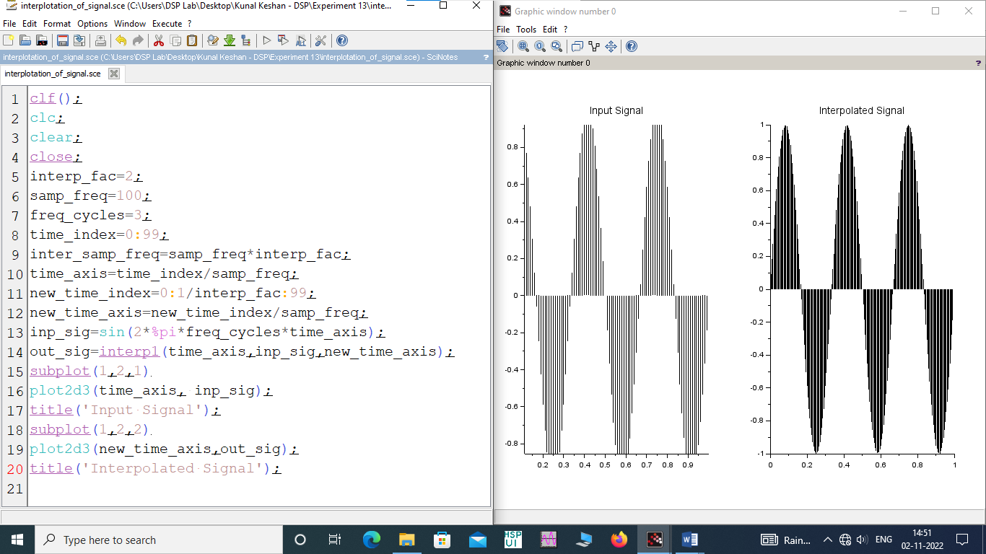

**Interpolation of Signal in Frequency Domain**

